Product Specification Sheet

Product name – XPT Rubber Traffic Lane Separators
Product code
747600
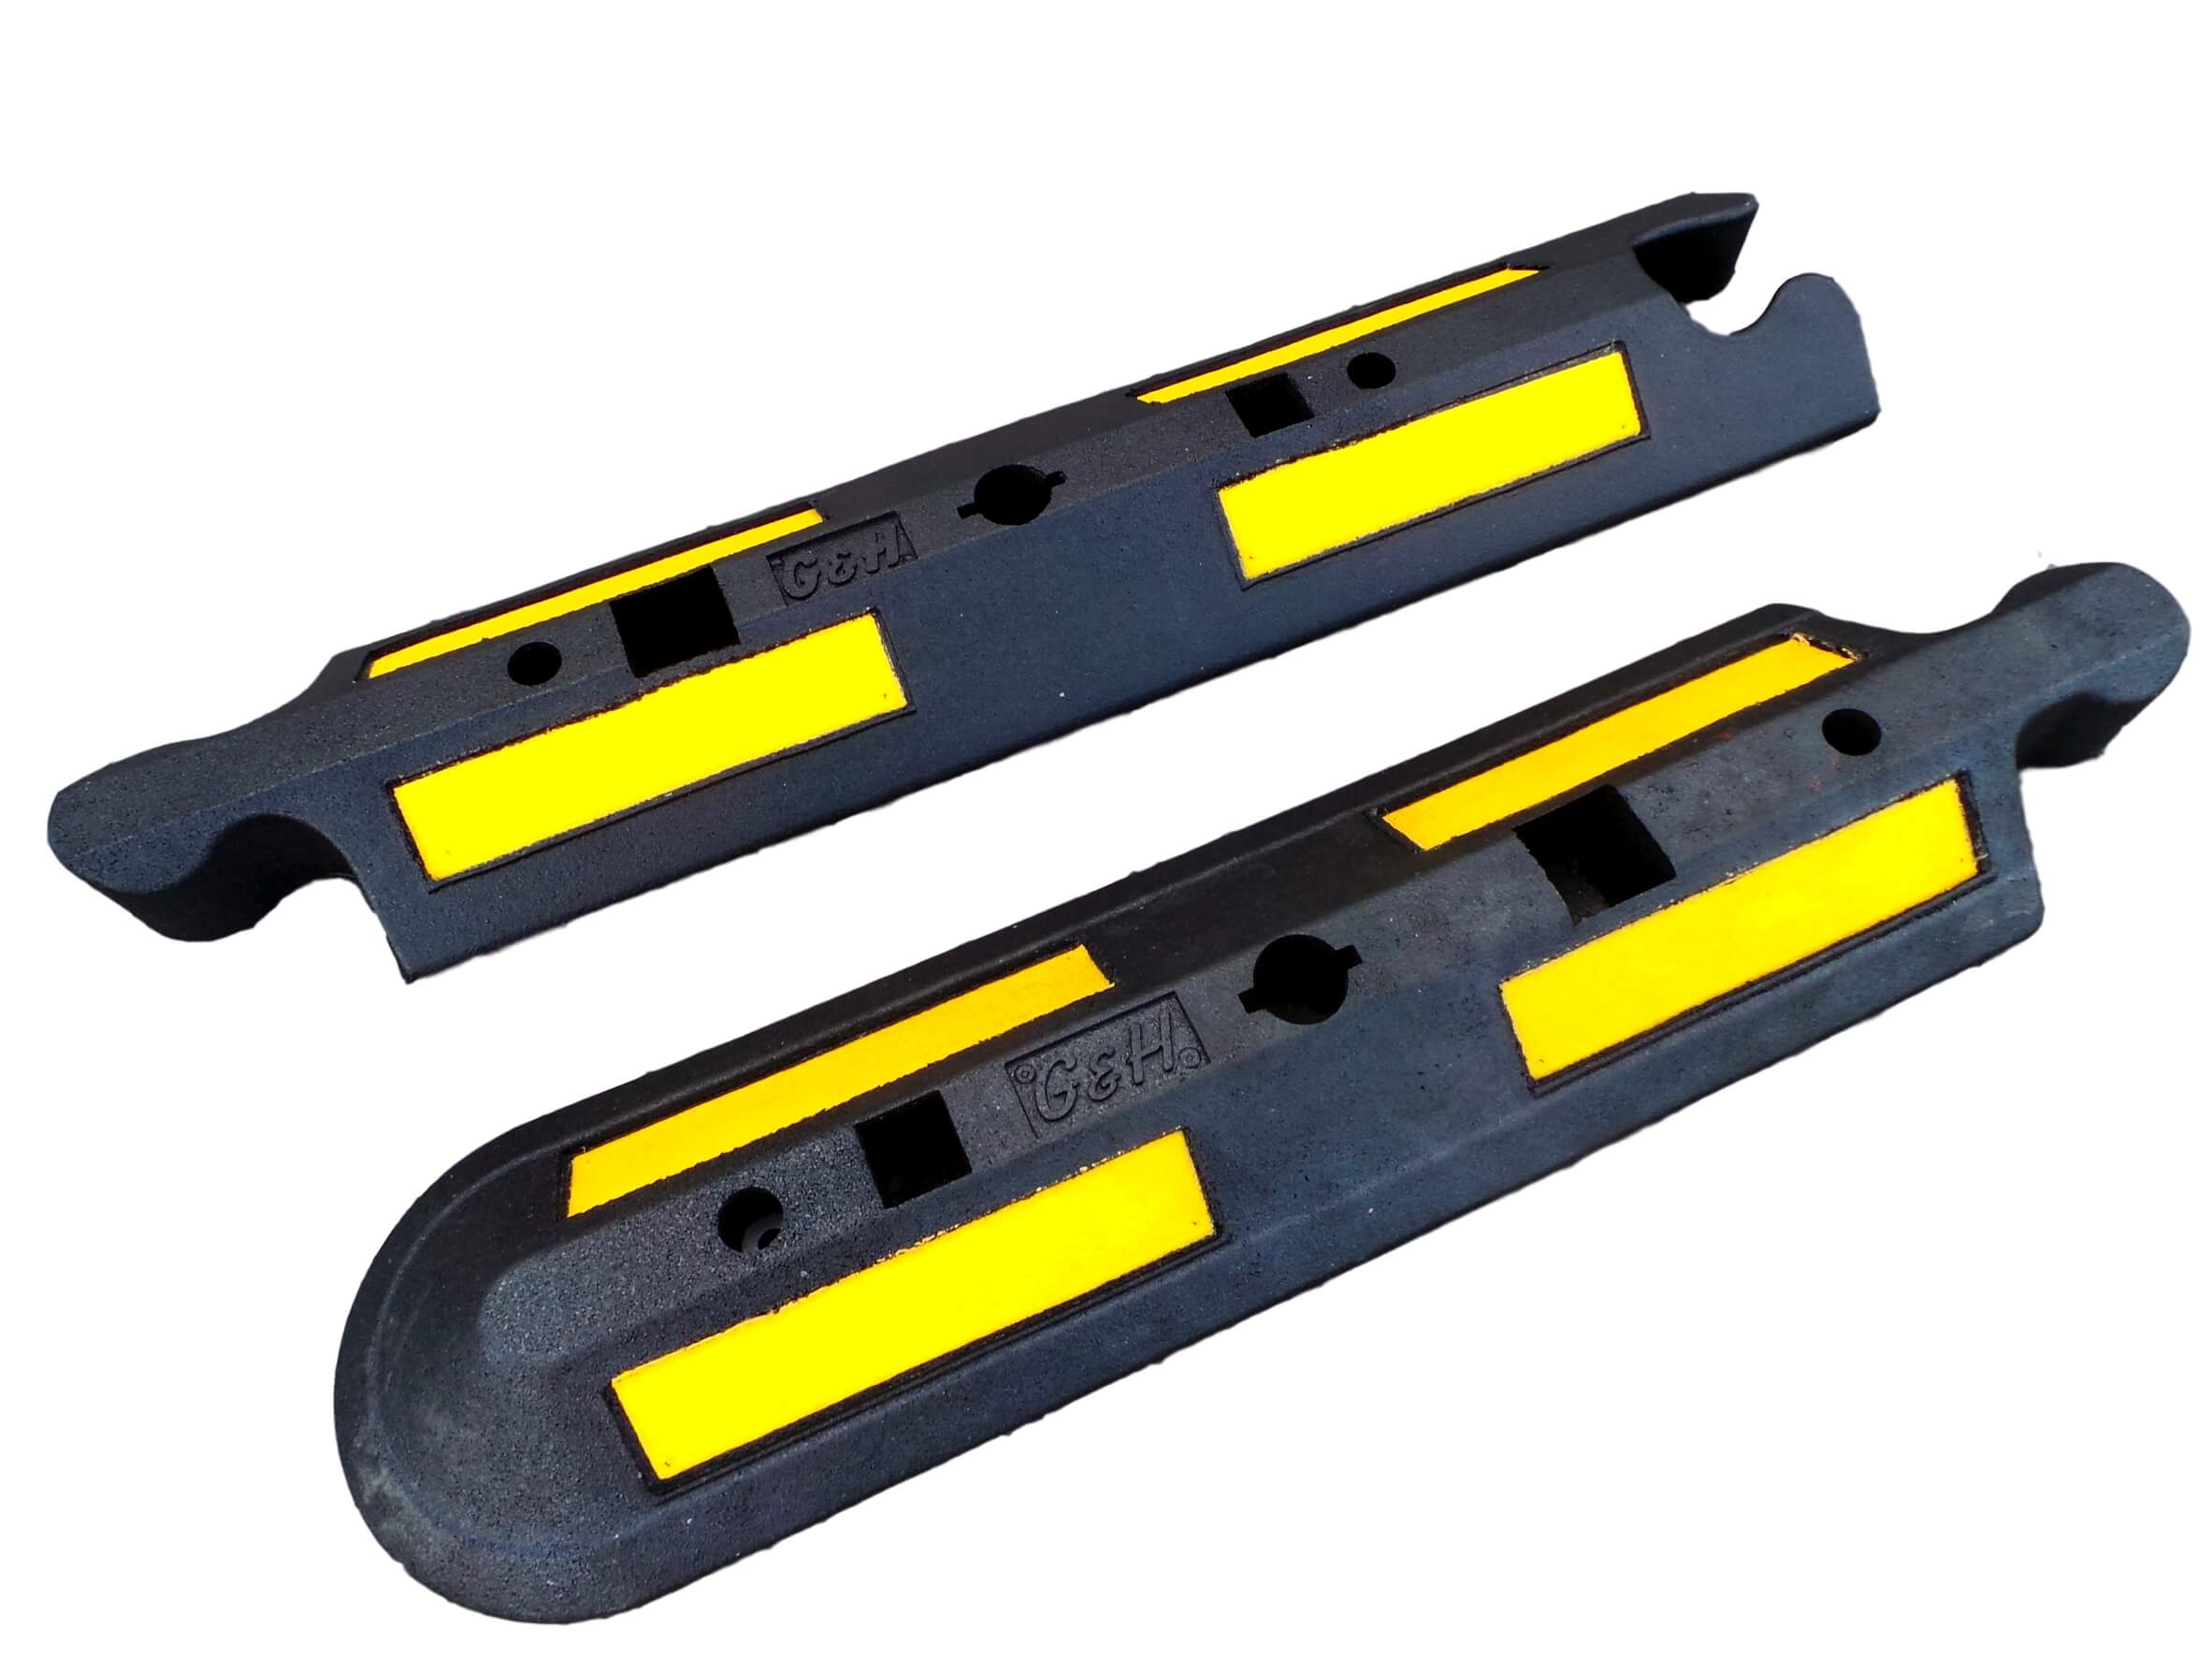

Manufacturer /  Brand | Geyer and Hosaja
Warranty | 1 Year manufacturer’s warranty
Material | 100% recycled rubber
Components | Single-piece middle and end-sections
Dimensions | Middle-section - 1130(L) x 240(W) x 80(H)mm  End-section – 1130(L) x 240(W) x 80(H)mm
Features | Modular design – easily extended when needed  Male and female ends – fast attaching on site  Bolt down via two fixing point per section  100% recycled rubber design – long-lasting  Moulded 3M reflective markings for increased visibility

